**PATFIN NURSERY AND PRIMARY SCHOOL, AKESAN, LAGOS STATE.**

**THIRD TERM EXAMINATION [2018 / 2019]**

**CLASS: KG 1**

**NAME: ______________________________________ SUBJECT: NUMBER WORK**

**INSTRUCTION: ANSWER ALL QUESTIONS DURATION: 1 HOUR**

1. Recite 2 times table orally
2. Count and write numbers ***1 – 70***

____ ____ ____ ____ ____ ____ ____ ____ ____ ____ ____ ____ ____ ____ ____ ____ ____ ____ ____ ____ ____ ____ ____ ____ ____ ____ ____ ____ ____ ____ ____ ____ ____ ____ ____ ____ ____ ____ ____ ____ ____ ____ ____ ____ ____ ____ ____ ____ ____ ____ ____ ____ ____ ____ ____ ____ ____ ____ ____ ____ ____ ____ ____

3. Fill in the gaps 1-70

1____2____3____5____7____9____11____13____15____17____19____21____23____25____27____29____31____33____35____37____39____41____43____45____47____49____51____53____55____57____59____61____63____65____67____69____

4. Match same numbers

60 55

59 56

58 57

57 58

56 59

55 60

5. Match numbers with object

5

7

12

3

6. Count and write how many

= _________________

=______________

= _______________________

= ____________________

**PATFIN NURSERY AND PRIMARY SCHOOL, AKESAN, LAGOS STATE.**

**THIRD TERM EXAMINATION [2018 / 2019]**

**CLASS: KG 1**

**NAME: ______________________________________ SUBJECT: LETTER-WORK**

**INSTRUCTION: ANSWER ALL QUESTIONS DURATION: 1 HOUR**

1. Demonstrate and sound letter A – Z

2. Write letters A-Z

____ ____ ____ ____ ____ ____ ____ ____ ____ ____ ____ ____ ____ ____ ____ ____ ____ ____ ____ ____ ____ ____ ____ ____ ____ ____ ____ ____

3. Fill in the gaps A-Z

A____C____E____G____I____K____M____O____Q____S____U____W____Y____

4. Match same letters

S Z

T Y

U X

V W

W V

X U

Y T

Z S

5. Write the first letter sound

 _______________

 __________

 __________________

 __________________

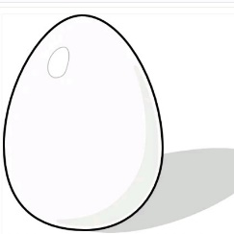 __________________

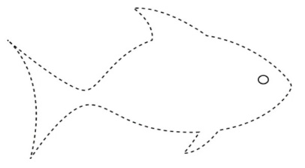 __________________

**PATFIN NURSERY AND PRIMARY SCHOOL, AKESAN, LAGOS STATE.**

**THIRD TERM EXAMINATION [2018 / 2019]**

**CLASS: HEAD START**

**NAME: ______________________________________ SUBJECT: NUMBER – WORK**

**INSTRUCTION: ANSWER ALL QUESTIONS DURATION: 1 HOUR**

1. Count numbers orally 1 – 50
2. Count and write 1 – 20

|  |  |  |  |  |  |  |  |  |  |
| --- | --- | --- | --- | --- | --- | --- | --- | --- | --- |
|  |  |  |  |  |  |  |  |  |  |
|  |  |  |  |  |  |  |  |  |  |

1. Fill in the gaps 1- 20

1 __________ 3 _______ 5 ________ 7 ______ 9 _______ 11 _____ 13 _______ 15 ________ 17 ______ 19 _______ .

1. Match same numbers

14 9

13 10

12 11

11 12

10 13

9 14

5. Count objects and match them to numbers

6

4

3

1

**PATFIN NURSERY AND PRIMARY SCHOOL, AKESAN, LAGOS STATE.**

**THIRD TERM EXAMINATION [2018 / 2019]**

**CLASS: HEAD START**

**NAME: ______________________________________ SUBJECT: LETTER – WORK**

**INSTRUCTION: ANSWER ALL QUESTIONS DURATION: 1 HOUR**

1. Sound these letters ;

*A , B , C , D , E , F , G , H , I , J*

1. Write letters A - M

|  |  |  |  |  |  |  |  |  |  |
| --- | --- | --- | --- | --- | --- | --- | --- | --- | --- |
|  |  |  |  |  |  |  |  |  |  |
|  |  |  |  |  |  |  |  |  |  |

1. Fill in the gaps **A – M**

___________ __________ ______ ________ __________ _____ ______ _______ ______ ________ _________ _________ ________ _______ _________ _______ _______ __________

1. Match same letters

F L

G K

H J

I I

J H

K G

L F

5. Write the first letter sound

 _______________

 __________

 __________________

 __________________

 __________________

 _________________

**PATFIN NURSERY AND PRIMARY SCHOOL, AKESAN, LAGOS STATE.**

**THIRD TERM EXAMINATION [2018 / 2019]**

**CLASS: NURSERY 1**

**NAME: ______________________________________ SUBJECT: LETTER – WORK**

**INSTRUCTION: ANSWER ALL QUESTIONS DURATION: 1 HOUR**

1. Count and write numbers 1 – 130.

|  |  |  |  |  |  |  |  |  |  |  |
| --- | --- | --- | --- | --- | --- | --- | --- | --- | --- | --- |
|  |  |  |  |  |  |  |  |  |  |  |
|  |  |  |  |  |  |  |  |  |  |  |
|  |  |  |  |  |  |  |  |  |  |  |
|  |  |  |  |  |  |  |  |  |  |  |
|  |  |  |  |  |  |  |  |  |  |  |
|  |  |  |  |  |  |  |  |  |  |  |
|  |  |  |  |  |  |  |  |  |  |  |
|  |  |  |  |  |  |  |  |  |  |  |
|  |  |  |  |  |  |  |  |  |  |  |
|  |  |  |  |  |  |  |  |  |  |  |
|  |  |  |  |  |  |  |  |  |  |  |
|  |  |  |  |  |  |  |  |  |  |  |
|  |  |  |  |  |  |  |  |  |  |  |

1. Fill in the gaps.

131 ______ 133 ________ 135 _____ 137 ______ 139 ________141 _______ 143 _____ 145 _________ 147 _______ 149 ______ 151 _______ 153 _________ 155 ______ 157 _______ 159 ______ 161 ________ 163 _______ 165 _______ 167 ______ 169 _______ 171 _____ 173 _______ 175 ______177 ________ 179 _______ 181 ______ 183 _____ 185 _____ 187 _______ 189 ______ 191______ 193 ______ 195 ______ 197 _____ 199 _____.

1. What says the time ( o’clock )?

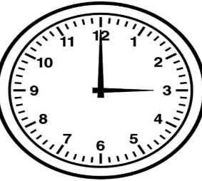 = _________ 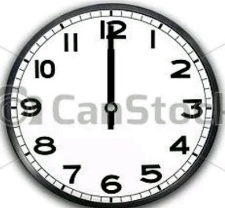 = ____________

1. Write in words;

2 = ____________ , 4 = _________ , 8 = ____________

1. Divide each object in half and shade.

1. Fill the containers;

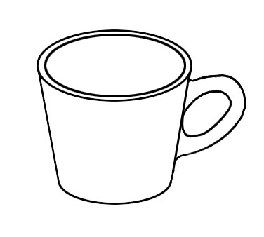  

Full Little Half

1. Addition of numbers ;
2. 5 + 3 =
3. 10 + 2 =
4. Write in Roman Numerals

3 = _________ , 1 = _________ , 7 = _____________

1. Subtract the following;

12 – 3 =

6 – 2 =

1. Multiply the following

3 x 5 =

**PATFIN NURSERY AND PRIMARY SCHOOL, AKESAN, LAGOS STATE.**

**THIRD TERM EXAMINATION [2018 / 2019]**

**CLASS: NURSERY 1**

**NAME: ______________________________________ SUBJECT: LETTER – WORK**

**INSTRUCTION: ANSWER ALL QUESTIONS DURATION: 1 HOUR**

1. Read and copy these simple sentences;
2. A Cup A big Cup

__________ ______________

A big red cup is on a mat.

_____________________________________ .

1. A Dog A big Dog

______ _____________

A big red Dog is sleeping on the log.

______________________________

1. Find the plural of the following;
2. .

|  |  |
| --- | --- |
| **SINGULAR** | **PLURAL ( s )** |
| Cat |  |
| Boy |  |
| Tap |  |
| Cup |  |

1. .

|  |  |
| --- | --- |
| **SINGULAR** | **PLURAL ( s )** |
| One toy |  |
| One Ant |  |
| One bag |  |
| One Cap |  |

1. Find the plural of these words;

|  |  |
| --- | --- |
| **SINGULAR** | **PLURAL ( s )** |
| Fish |  |
| Wish |  |
| Church |  |
| Dish |  |

1. Mention five(5) examples of a pronoun

________ , __________ , _________ , _________, ________

1. A Noun is a naming word of any person , animal , place or thing . [ True || False ]

***Circle out the noun from the following;***

1. Joy From Begin
2. Big Dog Take
3. Mention three(3) names you know;
4. ______________
5. _________________
6. ___________________

**PATFIN NURSERY AND PRIMARY SCHOOL, AKESAN, LAGOS STATE.**

**THIRD TERM EXAMINATION [2018 / 2019]**

**CLASS: KG 2**

**NAME: ______________________________________ SUBJECT: NUMBER – WORK**

**INSTRUCTION: ANSWER ALL QUESTIONS DURATION: 1 HOUR**

1. Count and write numbers 50 – 100

|  |  |  |  |  |  |  |  |  |  |
| --- | --- | --- | --- | --- | --- | --- | --- | --- | --- |
|  |  |  |  |  |  |  |  |  |  |
|  |  |  |  |  |  |  |  |  |  |
|  |  |  |  |  |  |  |  |  |  |
|  |  |  |  |  |  |  |  |  |  |
|  |  |  |  |  |  |  |  |  |  |

1. Simple Additions
2. 5 + 2 =

00000 00

1. 3 + 6 =

000 000000

1. 4 + 1 =
2. 0
3. Fill in the number gaps;

100 _____ 103 _____ 105 _____ 107 ______ 109 _______111 _______ 113 _____ 115 ______ 117 ______ 119 ______ 121 _____ 123 _____ 125 ____ 127 ______ 129 ______ 131 _____ 133 ____ 135 _____ 137 _____ 139 _____ 141 _____ 143 ______ 145 ______ 147 _____ 149 ________.

1. Multiplication tables. (2 Times)

2 x 1 =

00 0

2 x 2 =

00` 00

2 x 3 =

00 000

2 x 4 =

00 0000

2 x 5 =

00 00000

2 x 6 =

00 000000

1. Subtraction

4 -- 3 =

0000 000

7 -- 2 =

0000000

10 -- 1 =

0000000000

**PATFIN NURSERY AND PRIMARY SCHOOL, AKESAN, LAGOS STATE.**

**THIRD TERM EXAMINATION [2018 / 2019]**

**CLASS: KG 2**

**NAME: ______________________________________ SUBJECT: LETTER – WORK**

**INSTRUCTION: ANSWER ALL QUESTIONS DURATION: 1 HOUR**

1. Read and write capital and small letters. (Aa – Zz)

|  |  |  |  |  |  |  |  |  |  |
| --- | --- | --- | --- | --- | --- | --- | --- | --- | --- |
|  |  |  |  |  |  |  |  |  |  |
|  |  |  |  |  |  |  |  |  |  |
|  |  |  |  |  |  |

1. Blending two(2) letter words

O n

_________

I f

_________

U p

_________

A m

_________

1. Fill in the letter gaps

Aa ________ Cc _______ Ee ______ Gg _______ Ii ______ Kk _____ Mm _______ Oo _______ Qq ______ Ss ________ Uu _____ Ww _____ Yy ________.

1. Read and copy these two letter words .

It is in

__________________

Is it in ?

__________________

In it is

__________________

1. It is on

__________________

Is it on ?

_________________

On it is

__________________